1. Switch the DIP to the position as illustrated below。Next, Open the browser to enter the default network port ip address： http://192.168.0.178/：

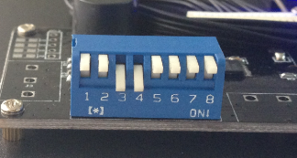

- If the authorization window pops up, enter the user name and password (BOTH are admin), and then click the OK button:

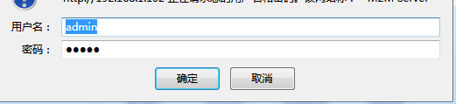

3.In the pop-up configuration page, click on the Network page, you can set the appropriate ip parameters, configure click submit button：

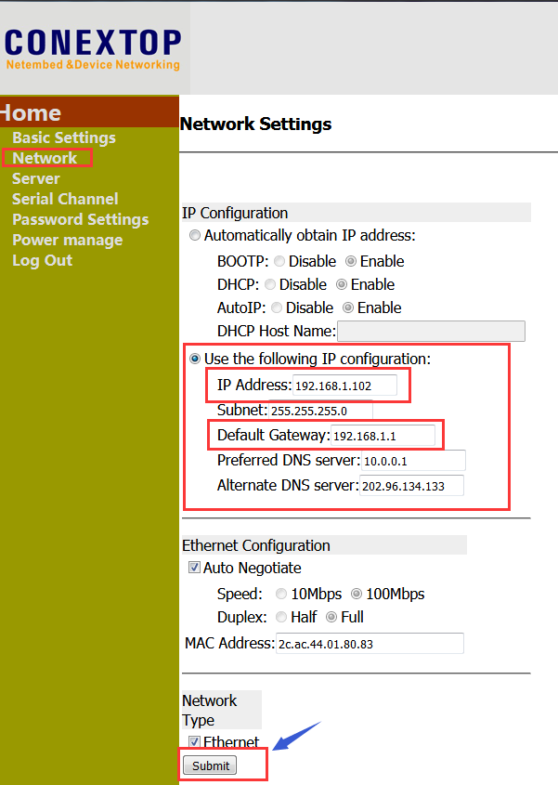

- In the Serial Channel page, click the "Serial" configuration, you can modify the baud rate value.

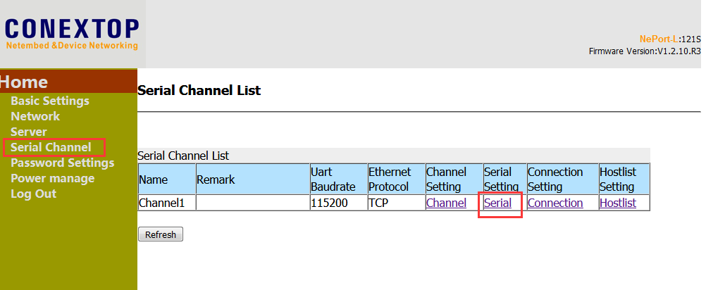

Click the Submit button as shown in the figure after setting.

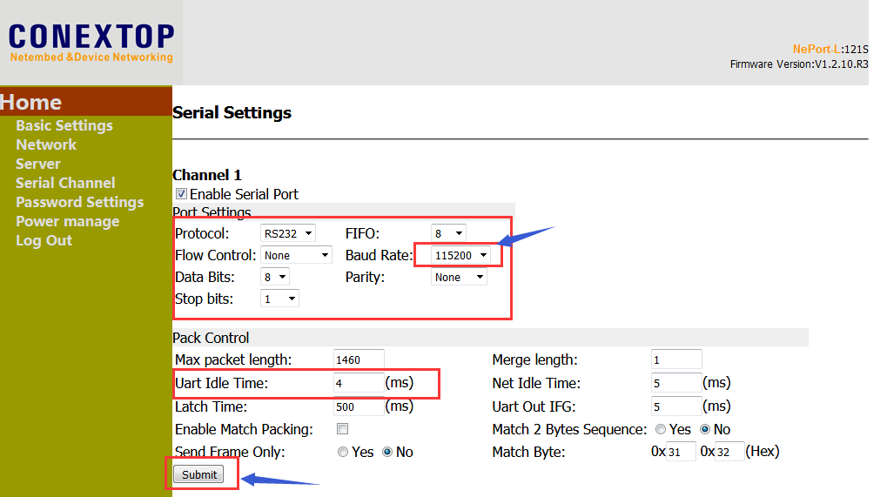

- In the Serial Channel page, click the "Connection" configuration, you can modify the network port working mode and port value.

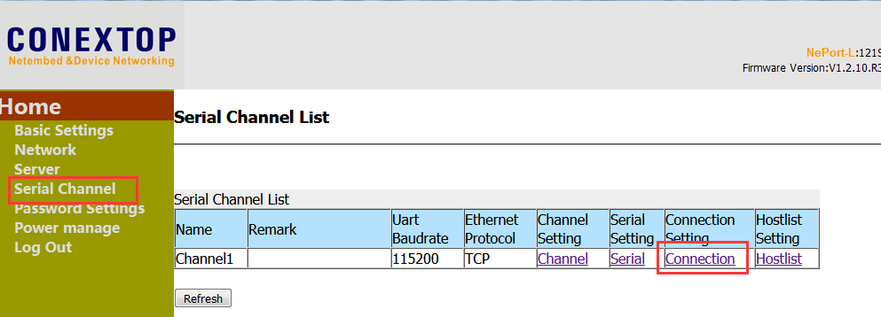

Click the Submit button as shown in the figure after setting.

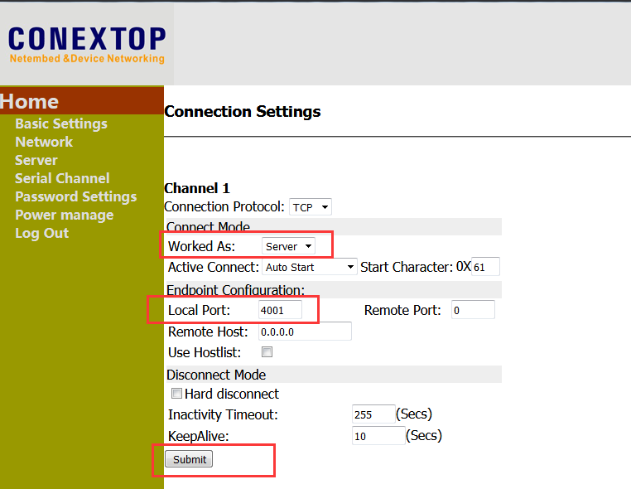

6.Save the settings and reboot the device：

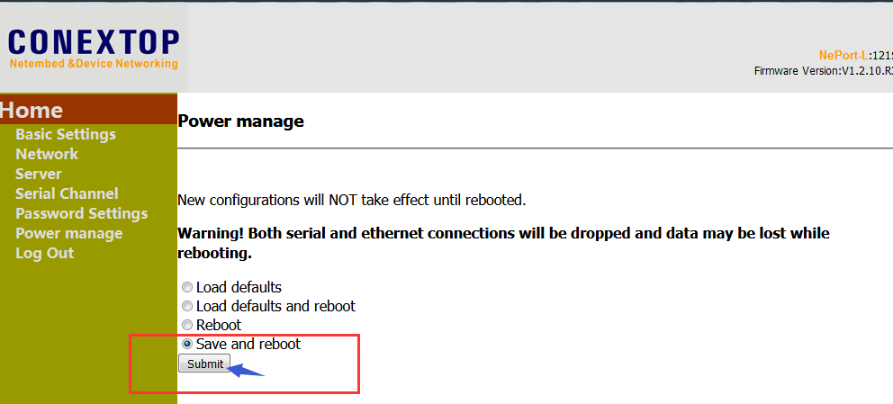

7. Connection demo software and test：

